**Results**

**Unemployment Rate by State in 2016**



**Unemployment Rate by State in 2015**



**Unemployment Rate by State in 2014**



**Unemployment Rate by State in 2013**



**Unemployment Rate by State in 2012**



**Unemployment Rate by State in 2011**



**Line Graph**

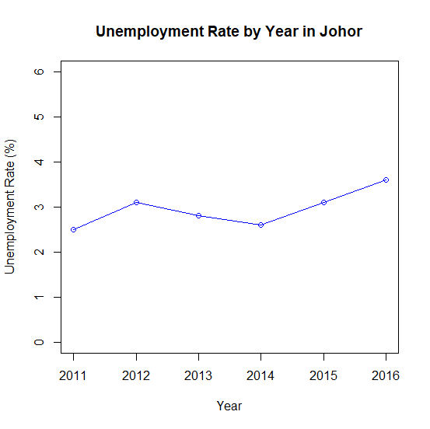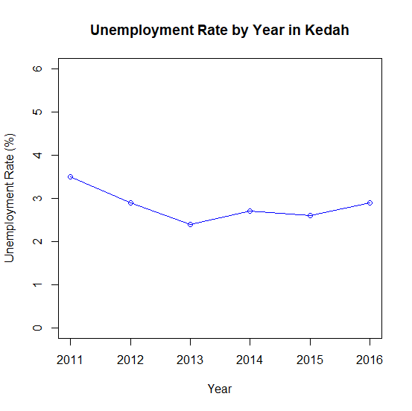

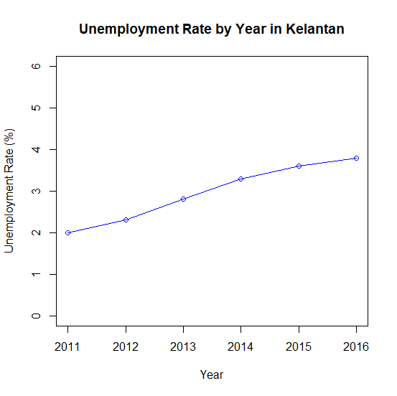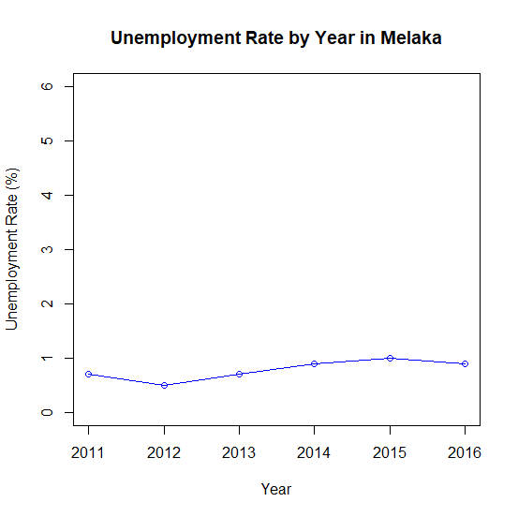

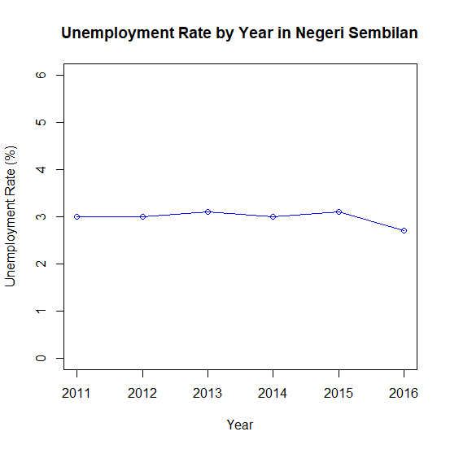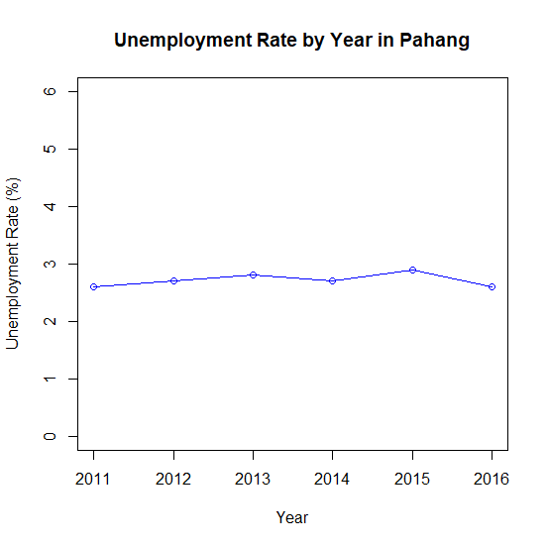

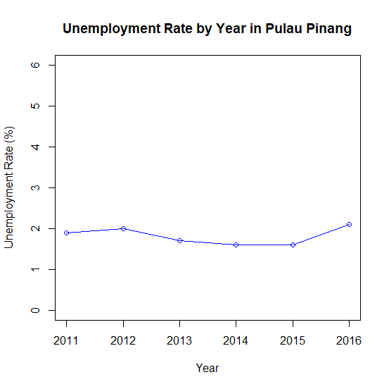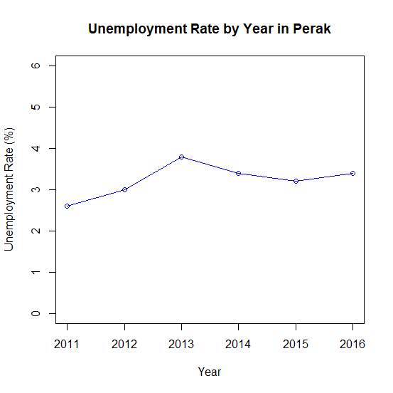

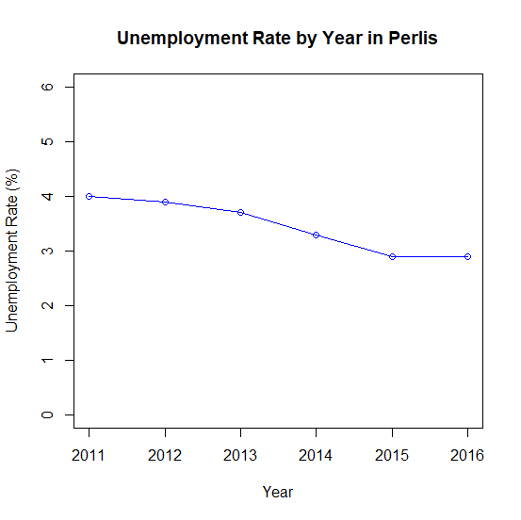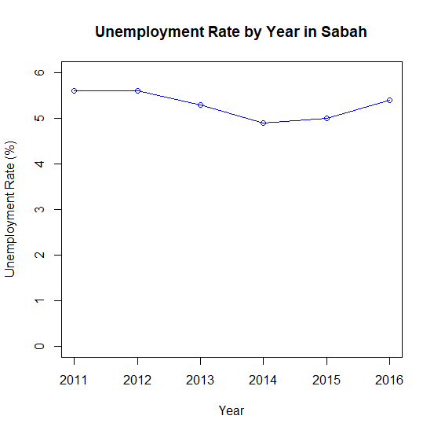

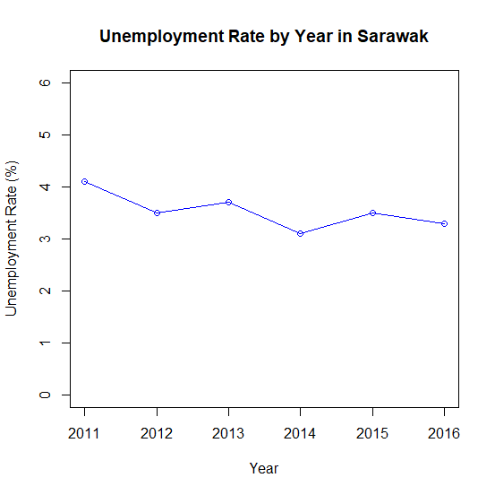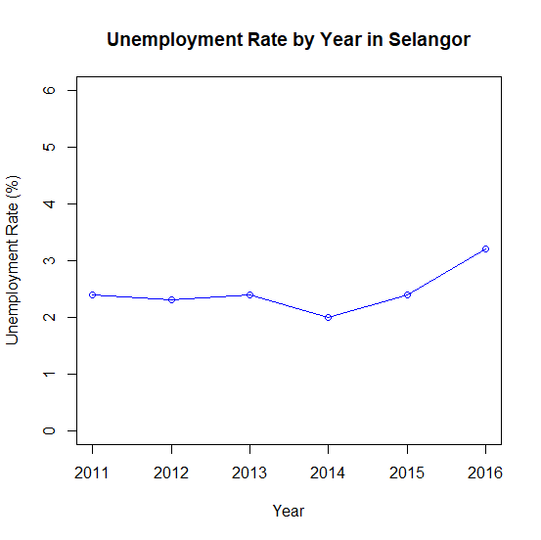

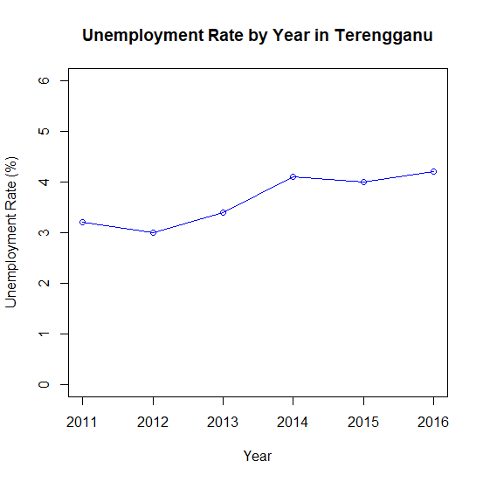

**Bar Chart**

**Legend**

**J – Johor**

**K - Kedah**

**D – Kelantan**

**M – Melaka**

**N – Negeri Sembilan**

**C – Pahang**

**A – Perak**

**R – Perlis**

**P – Pulau Pinang**

**S – Sabah**

**Q – Sarawak**

**B – Selangor**

**T - Terengganu**

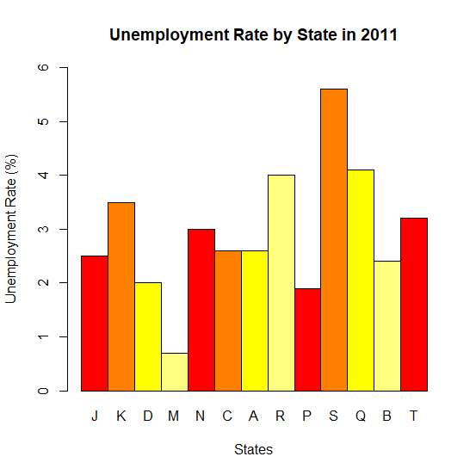

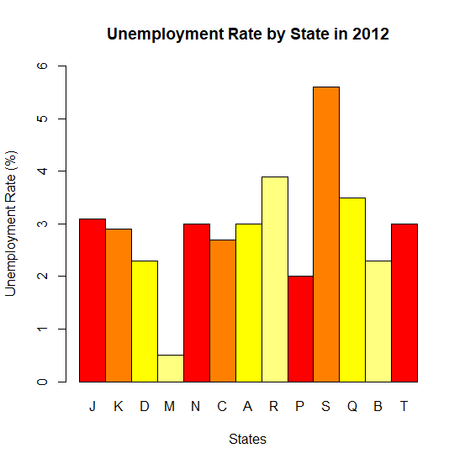

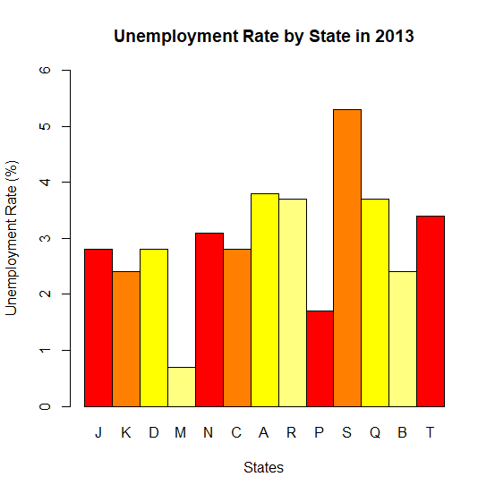

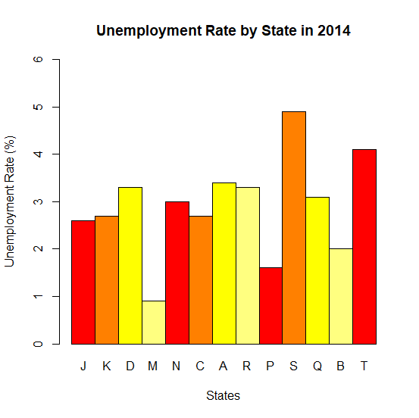

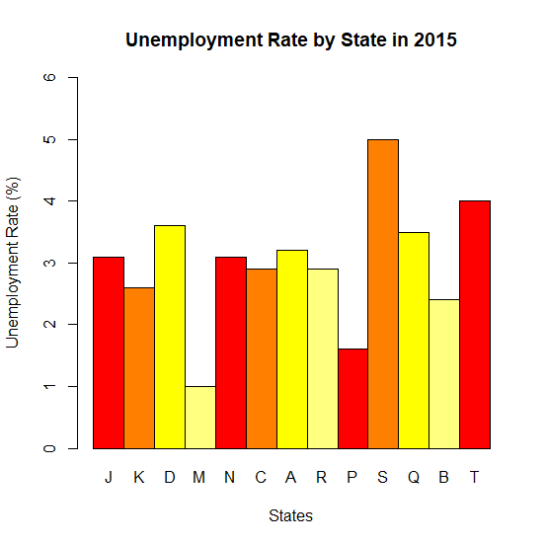

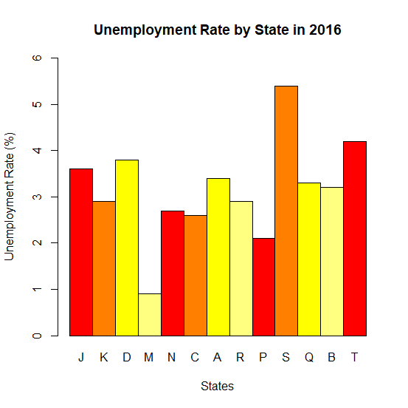

**Pie Chart**

**Legend**

**J – Johor**

**K - Kedah**

**D – Kelantan**

**M – Melaka**

**N – Negeri Sembilan**

**C – Pahang**

**A – Perak**

**R – Perlis**

**P – Pulau Pinang**

**S – Sabah**

**Q – Sarawak**

**B – Selangor**

**T - Terengganu**

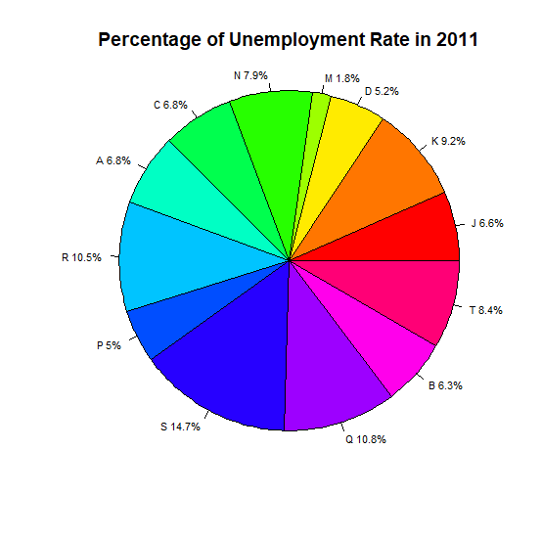

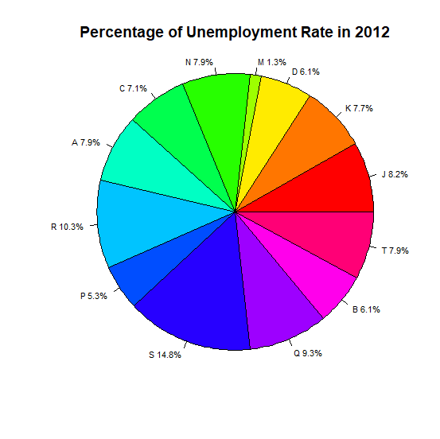

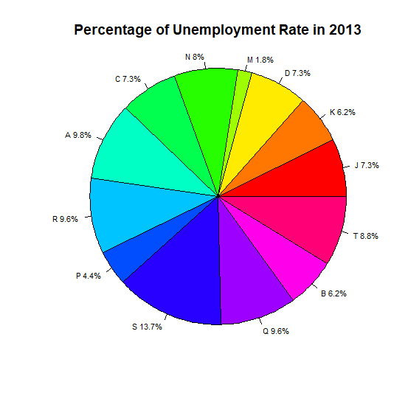

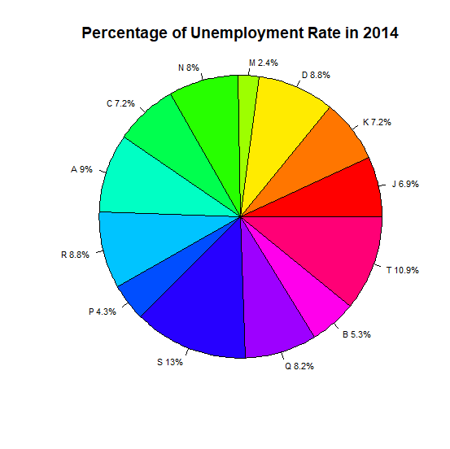

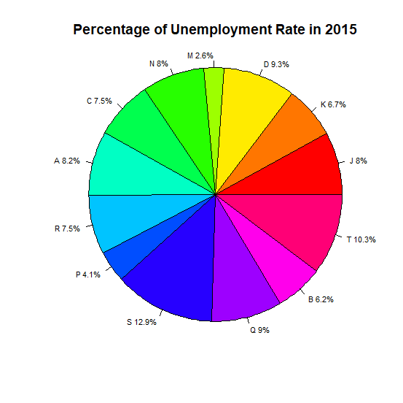

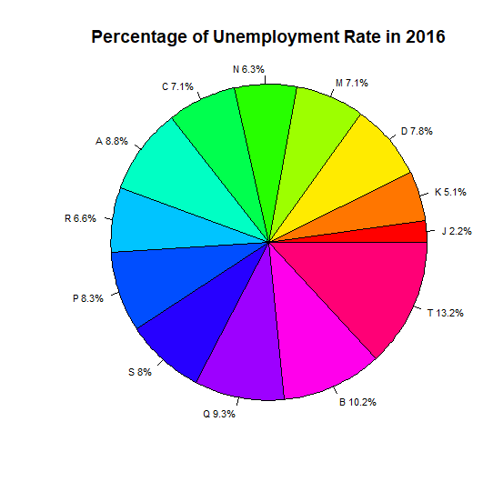

**Boxplot**

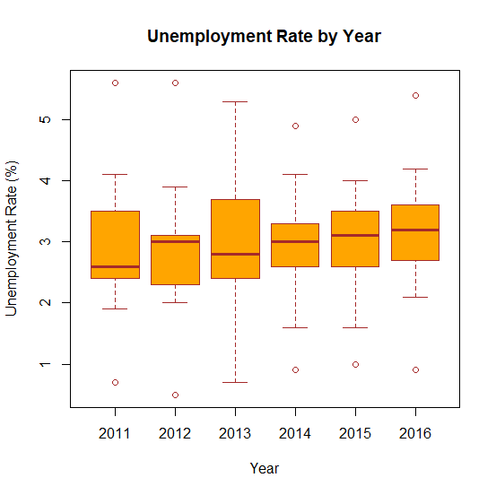

**Summary**



**Appendix**

**Line Graph**

plot(as.matrix(data[1:6,3])~as.matrix(data[1:6,2]), main="Unemployment Rate by Year in Johor", xlab="Year", ylab="Unemployment Rate (%)", xlim=c(2011, 2016), ylim=c(0, 6), col="blue")

lines(as.matrix(data[1:6,3])~as.matrix(data[1:6,2]), col="blue")

plot(as.matrix(data[7:12,3])~as.matrix(data[1:6,2]), main="Unemployment Rate by Year in Kedah", xlab="Year", ylab="Unemployment Rate (%)", xlim=c(2011, 2016), ylim=c(0, 6), col="blue")

lines(as.matrix(data[7:12,3])~as.matrix(data[1:6,2]), col="blue")

plot(as.matrix(data[13:18,3])~as.matrix(data[1:6,2]), main="Unemployment Rate by Year in Kelantan", xlab="Year", ylab="Unemployment Rate (%)", xlim=c(2011, 2016), ylim=c(0, 6), col="blue")

lines(as.matrix(data[13:18,3])~as.matrix(data[1:6,2]), col="blue")

plot(as.matrix(data[19:24,3])~as.matrix(data[1:6,2]), main="Unemployment Rate by Year in Melaka", xlab="Year", ylab="Unemployment Rate (%)", xlim=c(2011, 2016), ylim=c(0, 6), col="blue")

lines(as.matrix(data[19:24,3])~as.matrix(data[1:6,2]), col="blue")

plot(as.matrix(data[25:30,3])~as.matrix(data[1:6,2]), main="Unemployment Rate by Year in Negeri Sembilan", xlab="Year", ylab="Unemployment Rate (%)", xlim=c(2011, 2016), ylim=c(0, 6), col="blue")

lines(as.matrix(data[25:30,3])~as.matrix(data[1:6,2]), col="blue")

plot(as.matrix(data[31:36,3])~as.matrix(data[1:6,2]), main="Unemployment Rate by Year in Pahang", xlab="Year", ylab="Unemployment Rate (%)", xlim=c(2011, 2016), ylim=c(0, 6), col="blue")

lines(as.matrix(data[31:36,3])~as.matrix(data[1:6,2]), col="blue")

plot(as.matrix(data[37:42,3])~as.matrix(data[1:6,2]), main="Unemployment Rate by Year in Perak", xlab="Year", ylab="Unemployment Rate (%)", xlim=c(2011, 2016), ylim=c(0, 6), col="blue")

lines(as.matrix(data[37:42,3])~as.matrix(data[1:6,2]), col="blue")

plot(as.matrix(data[43:48,3])~as.matrix(data[1:6,2]), main="Unemployment Rate by Year in Perlis", xlab="Year", ylab="Unemployment Rate (%)", xlim=c(2011, 2016), ylim=c(0, 6), col="blue")

lines(as.matrix(data[43:48,3])~as.matrix(data[1:6,2]), col="blue")

plot(as.matrix(data[49:54,3])~as.matrix(data[1:6,2]), main="Unemployment Rate by Year in Pulau Pinang", xlab="Year", ylab="Unemployment Rate (%)", xlim=c(2011, 2016), ylim=c(0, 6), col="blue")

lines(as.matrix(data[49:54,3])~as.matrix(data[1:6,2]), col="blue")

plot(as.matrix(data[55:60,3])~as.matrix(data[1:6,2]), main="Unemployment Rate by Year in Sabah", xlab="Year", ylab="Unemployment Rate (%)", xlim=c(2011, 2016), ylim=c(0, 6), col="blue")

lines(as.matrix(data[55:60,3])~as.matrix(data[1:6,2]), col="blue")

plot(as.matrix(data[61:66,3])~as.matrix(data[1:6,2]), main="Unemployment Rate by Year in Sarawak", xlab="Year", ylab="Unemployment Rate (%)", xlim=c(2011, 2016), ylim=c(0, 6), col="blue")

lines(as.matrix(data[61:66,3])~as.matrix(data[1:6,2]), col="blue")

plot(as.matrix(data[67:72,3])~as.matrix(data[1:6,2]), main="Unemployment Rate by Year in Selangor", xlab="Year", ylab="Unemployment Rate (%)", xlim=c(2011, 2016), ylim=c(0, 6), col="blue")

lines(as.matrix(data[67:72,3])~as.matrix(data[1:6,2]), col="blue")

plot(as.matrix(data[73:78,3])~as.matrix(data[1:6,2]), main="Unemployment Rate by Year in Terengganu", xlab="Year", ylab="Unemployment Rate (%)", xlim=c(2011, 2016), ylim=c(0, 6), col="blue")

lines(as.matrix(data[73:78,3])~as.matrix(data[1:6,2]), col="blue")

**Bar Chart**

barplot(as.matrix(data[1:13,3]), beside=TRUE, names.arg=c("J", "K", "D", "M", "N", "C", "A", "R", "P", "S", "Q", "B", "T"), main="Unemployment Rate by State in 2016", xlab="States", ylab="Unemployment Rate (%)", ylim=c(0,6), col=heat.colors(4), border="black")

barplot(as.matrix(data[14:26,3]), beside=TRUE, names.arg=c("J", "K", "D", "M", "N", "C", "A", "R", "P", "S", "Q", "B", "T"), main="Unemployment Rate by State in 2015", xlab="States", ylab="Unemployment Rate (%)", ylim=c(0,6), col=heat.colors(4), border="black")

barplot(as.matrix(data[27:39,3]), beside=TRUE, names.arg=c("J", "K", "D", "M", "N", "C", "A", "R", "P", "S", "Q", "B", "T"), main="Unemployment Rate by State in 2014", xlab="States", ylab="Unemployment Rate (%)", ylim=c(0,6), col=heat.colors(4), border="black")

barplot(as.matrix(data[40:52,3]), beside=TRUE, names.arg=c("J", "K", "D", "M", "N", "C", "A", "R", "P", "S", "Q", "B", "T"), main="Unemployment Rate by State in 2013", xlab="States", ylab="Unemployment Rate (%)", ylim=c(0,6), col=heat.colors(4), border="black")

barplot(as.matrix(data[53:65,3]), beside=TRUE, names.arg=c("J", "K", "D", "M", "N", "C", "A", "R", "P", "S", "Q", "B", "T"), main="Unemployment Rate by State in 2012", xlab="States", ylab="Unemployment Rate (%)", ylim=c(0,6), col=heat.colors(4), border="black")

barplot(as.matrix(data[66:78,3]), beside=TRUE, names.arg=c("J", "K", "D", "M", "N", "C", "A", "R", "P", "S", "Q", "B", "T"), main="Unemployment Rate by State in 2011", xlab="States", ylab="Unemployment Rate (%)", ylim=c(0,6), col=heat.colors(4), border="black")

**Pie Chart**

pielabels<-c("J", "K", "D", "M", "N", "C", "A", "R", "P", "S", "Q", "B", "T")

pct<-round(as.matrix(data[1:13,3])/sum(as.matrix(data[1:13,3]))*100,1)

pielabels<-paste(pielabels, pct)

pielabels<-paste(pielabels, "%", sep="")

pie(as.matrix(data[1:13, 3]), labels=pielabels, edges=300, radius=1.0, angle=45, cex=0.7, col=rainbow(length(pielabels)), main="Percentage of Unemployment Rate in 2016")

pielabels<-c("J", "K", "D", "M", "N", "C", "A", "R", "P", "S", "Q", "B", "T")

pct<-round(as.matrix(data[1:13,3])/sum(as.matrix(data[1:13,3]))*100,1)

pielabels<-paste(pielabels, pct)

pielabels<-paste(pielabels, "%", sep="")

pie(as.matrix(data[1:13, 3]), labels=pielabels, edges=300, radius=1.0, angle=45, cex=0.7, col=rainbow(length(pielabels)), main="Percentage of Unemployment Rate in 2015")

pielabels<-c("J", "K", "D", "M", "N", "C", "A", "R", "P", "S", "Q", "B", "T")

pct<-round(as.matrix(data[1:13,3])/sum(as.matrix(data[1:13,3]))*100,1)

pielabels<-paste(pielabels, pct)

pielabels<-paste(pielabels, "%", sep="")

pie(as.matrix(data[1:13, 3]), labels=pielabels, edges=300, radius=1.0, angle=45, cex=0.7, col=rainbow(length(pielabels)), main="Percentage of Unemployment Rate in 2014")

pielabels<-c("J", "K", "D", "M", "N", "C", "A", "R", "P", "S", "Q", "B", "T")

pct<-round(as.matrix(data[1:13,3])/sum(as.matrix(data[1:13,3]))*100,1)

pielabels<-paste(pielabels, pct)

pielabels<-paste(pielabels, "%", sep="")

pie(as.matrix(data[1:13, 3]), labels=pielabels, edges=300, radius=1.0, angle=45, cex=0.7, col=rainbow(length(pielabels)), main="Percentage of Unemployment Rate in 2013")

pielabels<-c("J", "K", "D", "M", "N", "C", "A", "R", "P", "S", "Q", "B", "T")

pct<-round(as.matrix(data[1:13,3])/sum(as.matrix(data[1:13,3]))*100,1)

pielabels<-paste(pielabels, pct)

pielabels<-paste(pielabels, "%", sep="")

pie(as.matrix(data[1:13, 3]), labels=pielabels, edges=300, radius=1.0, angle=45, cex=0.7, col=rainbow(length(pielabels)), main="Percentage of Unemployment Rate in 2012")

pielabels<-c("J", "K", "D", "M", "N", "C", "A", "R", "P", "S", "Q", "B", "T")

pct<-round(as.matrix(data[1:13,3])/sum(as.matrix(data[1:13,3]))*100,1)

pielabels<-paste(pielabels, pct)

pielabels<-paste(pielabels, "%", sep="")

pie(as.matrix(data[1:13, 3]), labels=pielabels, edges=300, radius=1.0, angle=45, cex=0.7, col=rainbow(length(pielabels)), main="Percentage of Unemployment Rate in 2011")

**Boxplot**

boxplot(Rate~Year,data=data,main="Unemployment Rate by Year",xlab="Year",ylab="Unemployment Rate (%)",col="orange",border="brown")

**Mean**

mean (as.matrix (data[1:13,3])

mean (as.matrix (data[14:26,3])

mean (as.matrix (data[27:39,3])

mean (as.matrix (data[40:52,3])

mean(as.matrix (data[53:65,3])

mean (as.matrix (data[66:78,3])

**Standard Deviation**

sd (as.matrix (data[1:13,3])

sd (as.matrix (data[14:26,3])

sd (as.matrix (data[27:39,3])

sd (as.matrix (data[40:52,3])

sd(as.matrix (data[53:65,3])

sd (as.matrix (data[66:78,3])

**Variance**

var (as.matrix (data[1:13,3])

var (as.matrix (data[14:26,3])

var (as.matrix (data[27:39,3])

var (as.matrix (data[40:52,3])

var (as.matrix (data[53:65,3])

var (as.matrix (data[66:78,3])

**Total**

sum (as.matrix (data[1:13,3])

sum (as.matrix (data[14:26,3])

sum (as.matrix (data[27:39,3])

sum (as.matrix (data[40:52,3])

sum (as.matrix (data[53:65,3])

sum (as.matrix (data[66:78,3])